OUR COMPANY

Hi, we are Phil. Fibertech Industries, lnc a wholly-owned

One part of our business involves making fiberglass products for the industrial market.

Another unit focuses on specialized systems for sport and institutions.

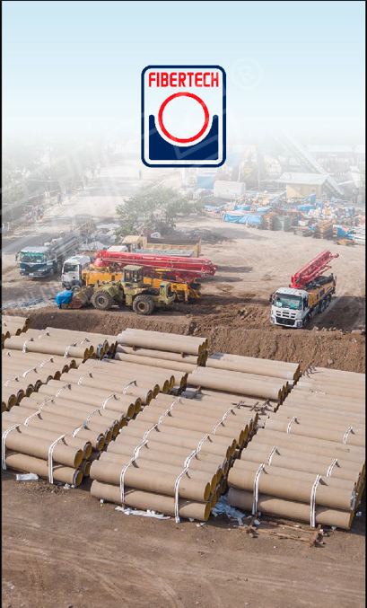

OUR ENTRY TO THE MARKET

You might wonder what a fiberglass company has to do with sports. This thing on the right has a lot to do with it and it is fiberglass.

Contrary to popular belief, fiberglass is not a transparent material. In the early 90’s and even to this date, people confuse it for the material used in basketball backboards.

This misconception has led us to discover and serve a market that is very close to the hearts of a lot of Filipinos: Basketball and Sports.



WE STARTED WITH A GOAL

We learned a lot in our experience in providing solutions to challenging industrial projects.

It was in the 90’s and we understood how important

Basketball is for us Filipinos. We set out to design and manufacture the finest locally-made basketball goals we could make 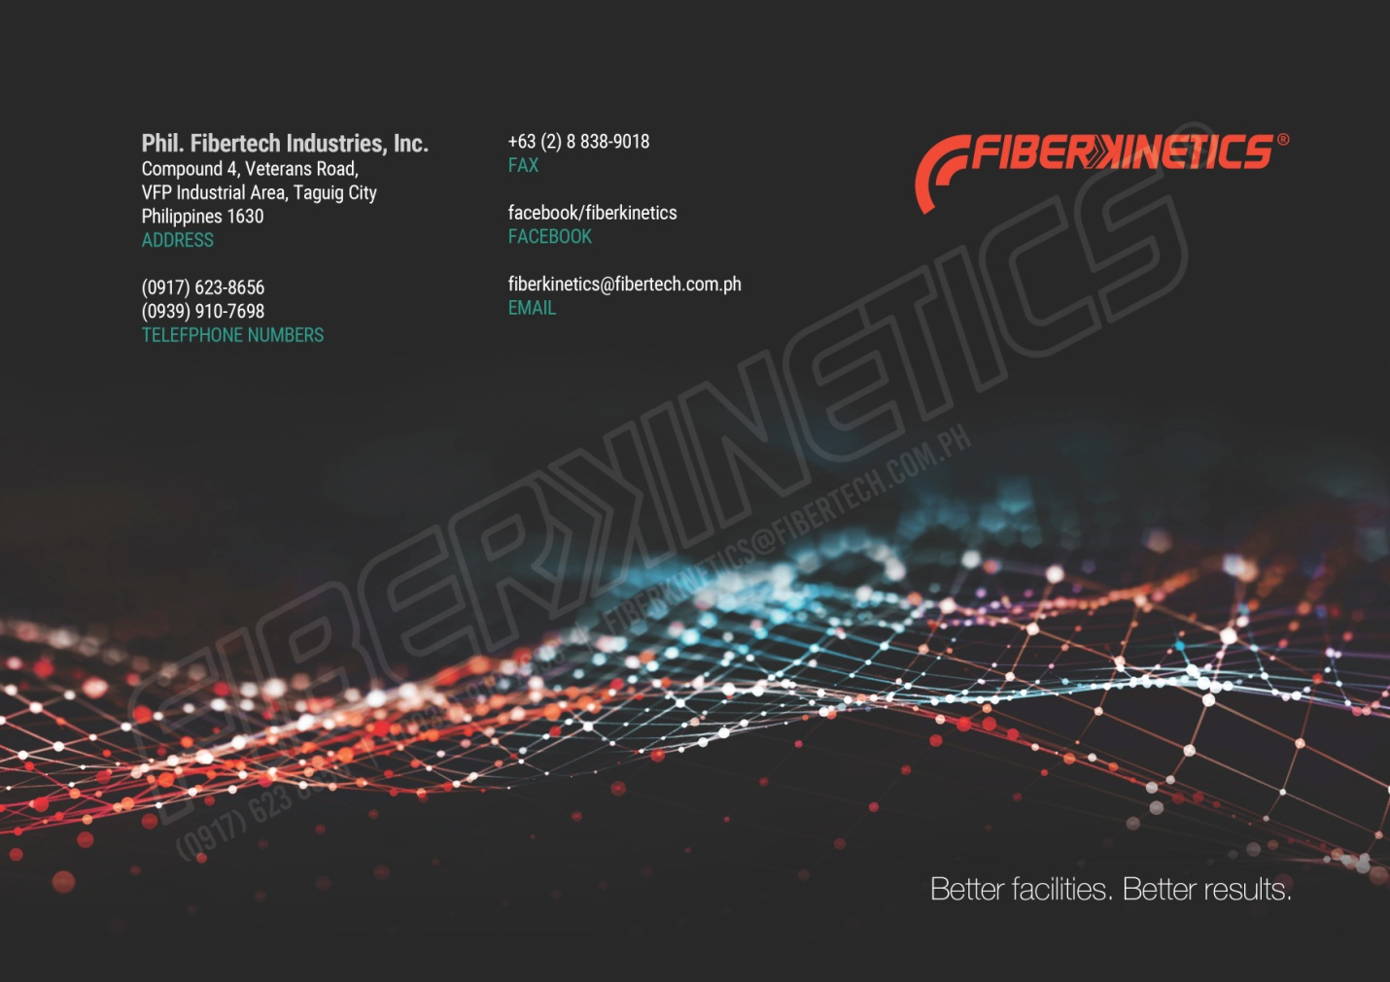since 1994.

Photo on the right: Early 2000’s Well-mounted Basketball Goal System.

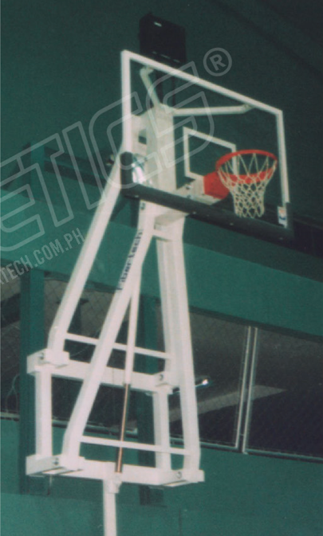

A FOCUSED BUSINESS UNIT

In 2011, the FiberKinetics business was formed,

continuing the high standards that we have set for ourselves when we started serving the industry.

We now have a comprehensive line of products from amazing brands that provide a lot of value for sports architecture and construction projects around the country.



STRONG PARTNERSHIP

In PBA’s long 47-history, we are very happy to have been trusted by the league as the first exclusive PBA Licensee for Sport Equipment and flooring

This partnership provides us valuable insight on how our product and solutions meet PBA’s high standards and make our projects for sports facilities across the country even better.

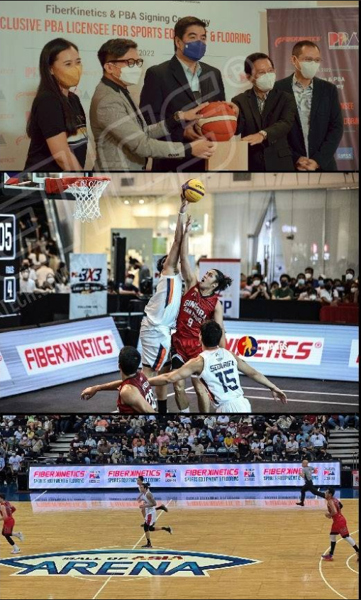

INSTITUTIONAL GRADE

Protecting Decades of Excellence

Institutions have built their name and reputation for many years

We have great best brands from around the world that provide a class of products that fulfill the highest standards for sports related equipment and systems trusted by institutions and facilities worldwide.

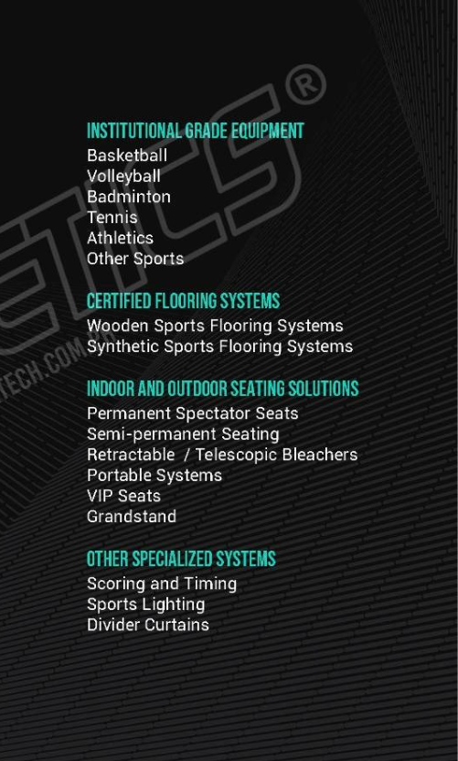

TRANSFORMING FACILITIES

More Clarity, Greater Possibilities.

There are so many consideration in finding thje right system for your projecvts. Various sports governing bodies, many products, many variants.

We guide our clients and equipment them with valuable information for them to make informations and explore possibilities that make their facilitiesd better.

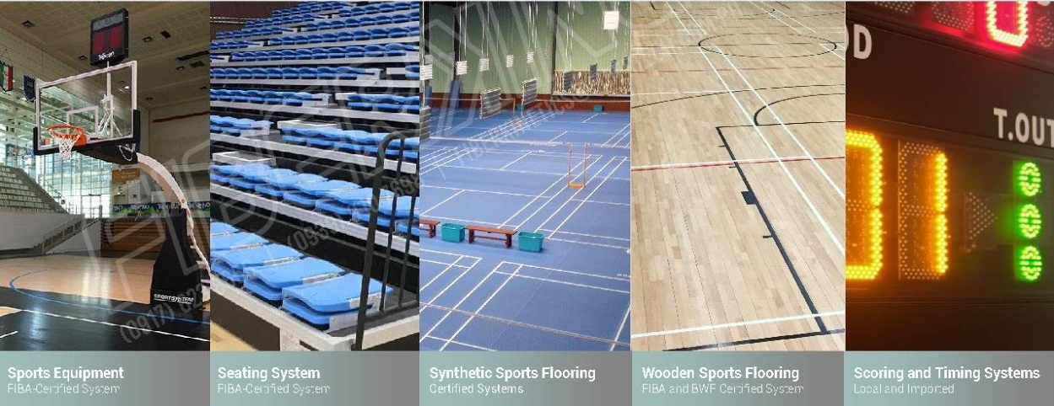

DEPENDABILITY

When It Matters, Where It Matters.

We focus our products and services to serve insitutions, facilities, and venues where people congregate together.

These venues rely on products that excellently perform in the heat of competition and consistently well during the rigors of frequent training.

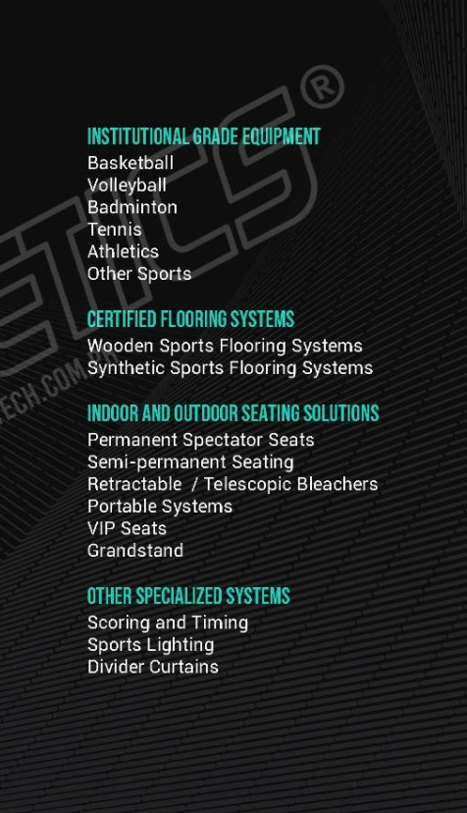

We continue to improve facilities through our products. Our projects help build better communities and provide well-equipped venues that foster and inspire the countr’s that foster and inspire the country’s champions within and beyond the sport.



WHY COOSE US?

CURATYED BRANDS

We carefully select the brands that we carry based on the advantage and capability it can provide to our project and clients.

COLLABORATIVE APPROACH

We seek out to understand your project’s unique requirements and guide ou through the many considerations of selecting the best system for you.

EXCEPTIONAL FACILITIES FOR THE FILIPINO

We work with industry experts from around the world through our partner brands to make your facility as good as we can. We don’t cut corners and deliver authentic, well0matched systems for your facility.

GENERATE MORE VALUE

Our products add value to your facility by giving you an edge over the competition.

INCREASE PREFERENCE FOR YOUR FACILITY

By providing consistent, quality equipment, we provide a playing experience comparable to imprted brands and this helps develop a preference for your facility leadfing to more bookings and a faster return

MINIMIZE VARIABLES

We set out to provide a neutral environment for skill and hard work to shine. Our products perform consistently, minimizing variables that can affect the game.

WE CARE ABOUT YOUR FACILITY

Reliablitiy plays a crucial role in operating your facility somoothly. With proper use and maintenance, you can rely on our products to noit only serve you wellm but perform consistently throughout its life.

Our quality products are backed by after sales support. We are always eager to collaborate with you on how you can maximize our pdoructs.

CONSITENT EQUIPMENT

30-50%

Energy Absorption by the System,

As recommended by NCAA and FIBA, the system should have an energy absorption competitive play.

95%

Response similarity for each pair\

We calibrate each pair of goals to the allowable range and fine tune both to be with 5% of each goal’s reading for similar response for both gfoals.

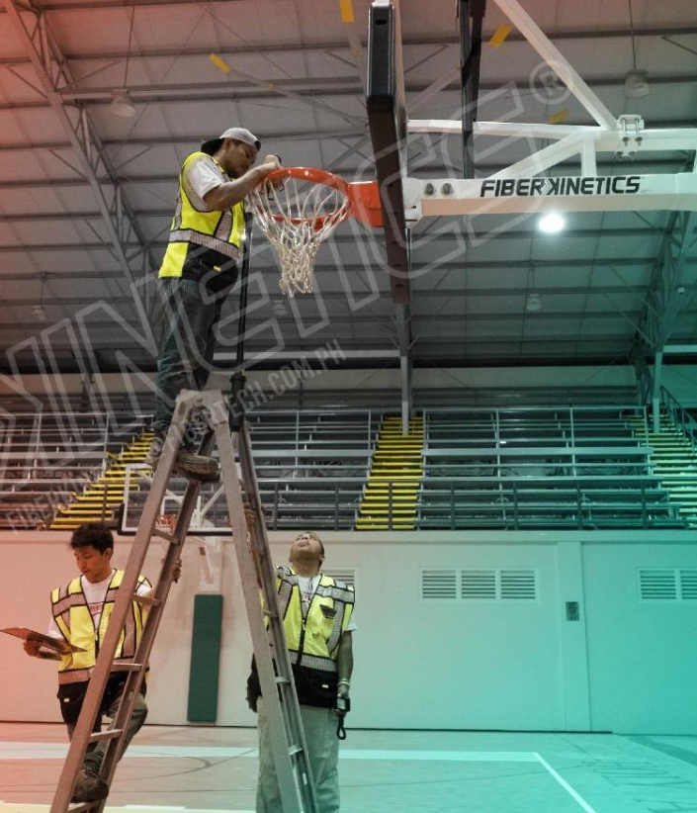

WE CONNECT

We work with architects, designers, specifications writers, contractors, politicians, and business owners and help them realize their projecty’s goals.

We build trust with our sincere mission to provide better facilities for the Filipino.

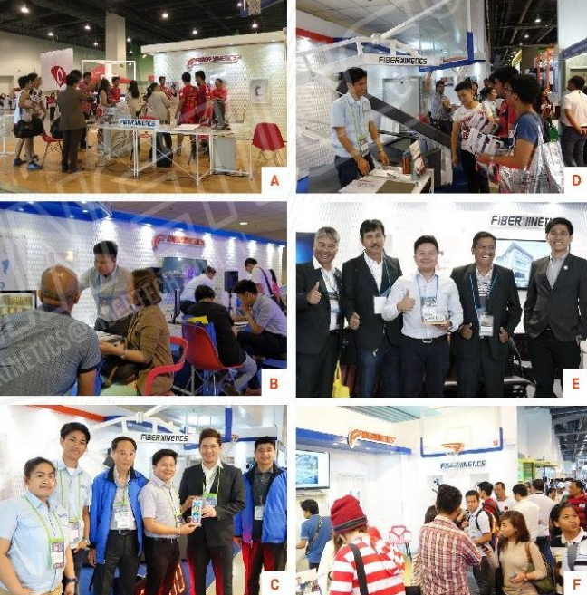

WE ENGAGE THE INDUSTRY

We do our best to understand the needs of our cluients and find solutions the best answer those needs. We explore ways on how we can help improve the industry, and that is why and how we found you

A An international Summit for Sports Cenues and Facilitiies.

B Meeting with an LGU to understand their objectives and challenges

C Participaating in events.

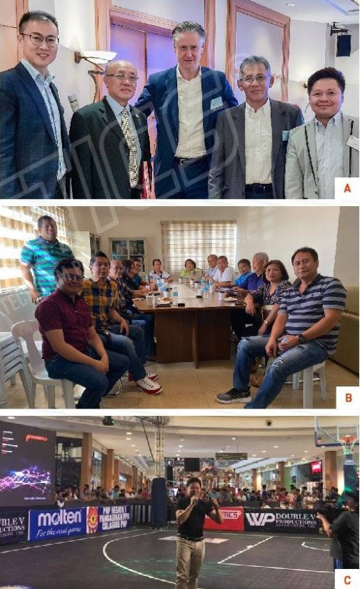

WE PROVIDE BETTER EXPERIENCES

It gives joy in seeing our projects become venues enjoyed by many.

Wer actively participate in activities that engage communities and create positive memories and shared experiences.

A doc allan cup 2019

B RC Cola Finals 2019

C Maharlika Vilalge Experience 2019

D Red Bull Reign Philippines Finals 2019

E Freestyle Hoopers 3-pt. Competition 2019

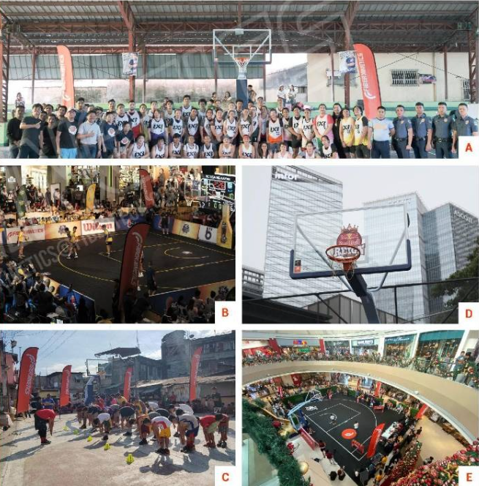

“Because the game of basketball has increasingly becoming global, Fiberkinetics, a Filipino-owned company, has taken a giant step to revolutionize the way Filipinos ballers play.”

Source : manilastandard.net

Article: state-of-the-art equipment for world-class-Filipino ballers

Date : feb 22, 2020

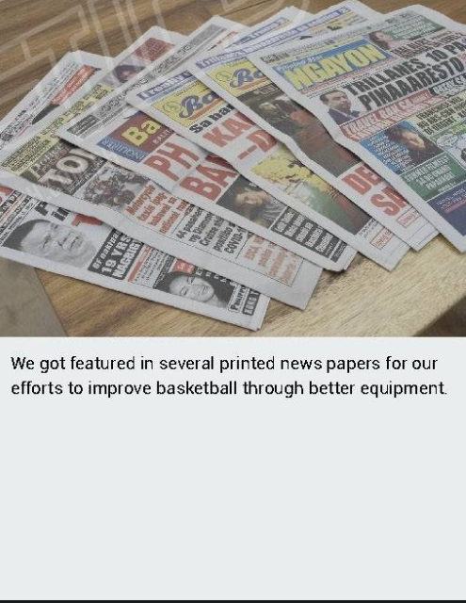

WE CAN DO MORE WITH YOU

It gives us great joy and a sense of contribution to a greater good with every project competition. We uynderstand that these projects unite, inspire, and develop individual and communities.

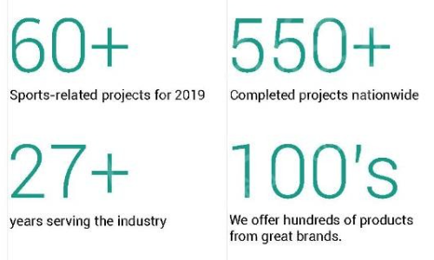

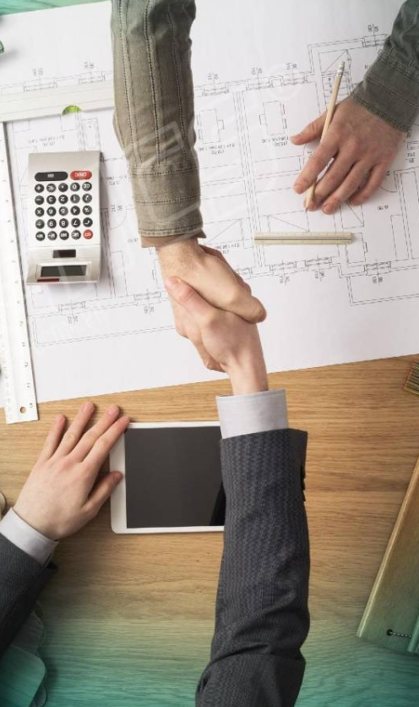

SOME PROJECTS

This is a residential development located very close to the Business District.

We provided our very own goal systems and volleyball post system, adding value to the property’s amenities.

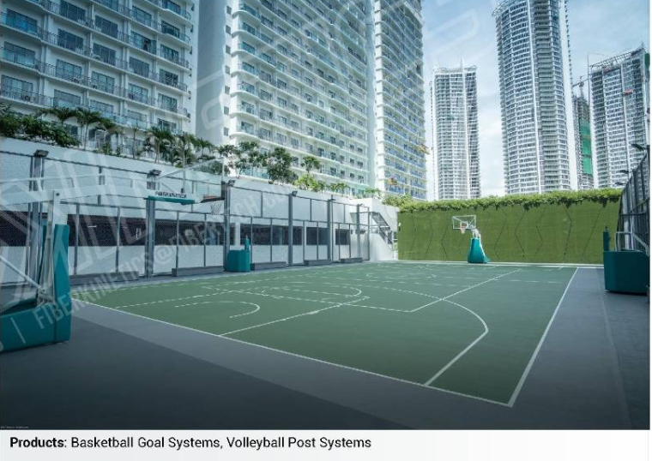

SOME PROJECTS

This is a multi-purpose court with a particular objective of setting a higher standard to serve its people better

The result was a court that unified the community and became a source of admiration from other nearby communities to emulate.

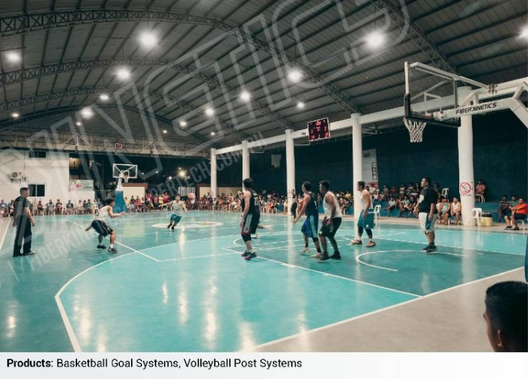

SOME PROJECTS

The project is part of a mixed-use development in Quezon City.

Primarily a residential development, the 12.47 hectare riverfront community is one of the four major estates owned and developed by the Ortigas & Companmy in Metro Manila.

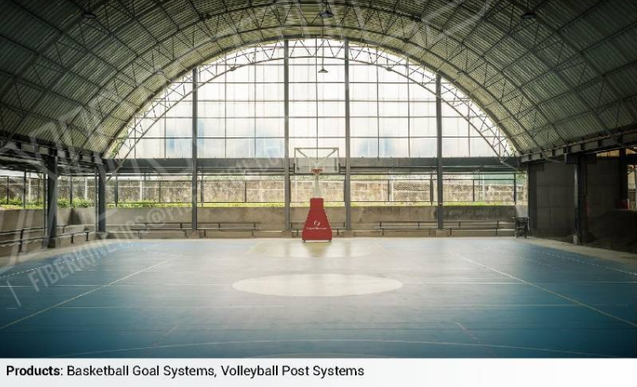

SOME PROJECTS

The University of Asia and the pacific is a private, not-for-profit institution of higher learning that offers some of the most outstanding academic programs in Asia.

This multi-level facility allows for its students to continue raising the bar for the university’s athletes.

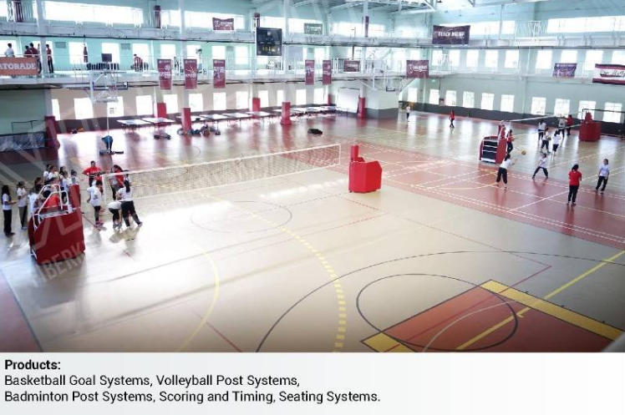

SOME PROJECTS

The University of Philippines Baguio Human Kinetics Program continues to provide advanced instruction and research in the human movement sciences.

This well-equipped facility provides its students with a good environments to further theor development in sports.

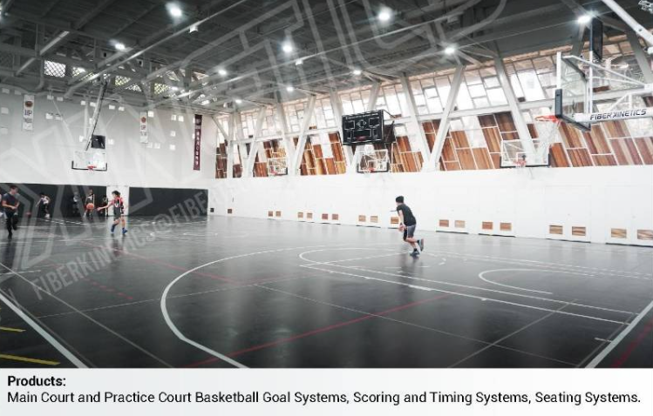

SOME PROJECTS

Currently learning institution;s largest sports facility and serves as a venue for their sporting events, varsity training and development, university-wide activites, as well as major events in the city.

The retractable seating system we provided allowed for great flexibility in adding more capability and maximizing their space.

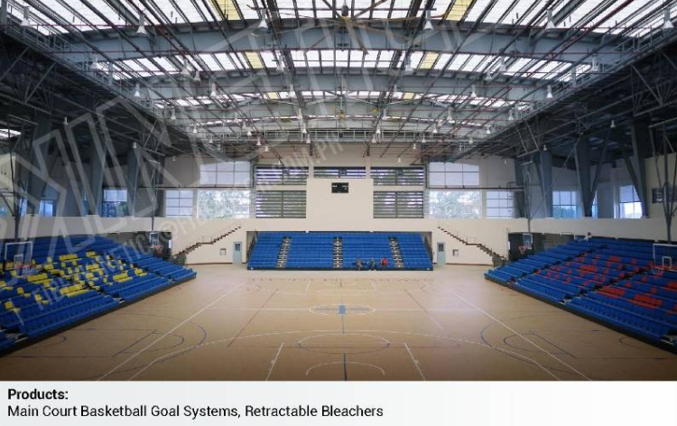

BUILT ON TRUST. PROVEN BY TIME

It is privilege to serve some of the country;s largest, and most respected establishments and institutions.

We have recurring business with many of these discerning clients. We attribute this to our ability to consistently deliver our promise our clients and their stakeholders.

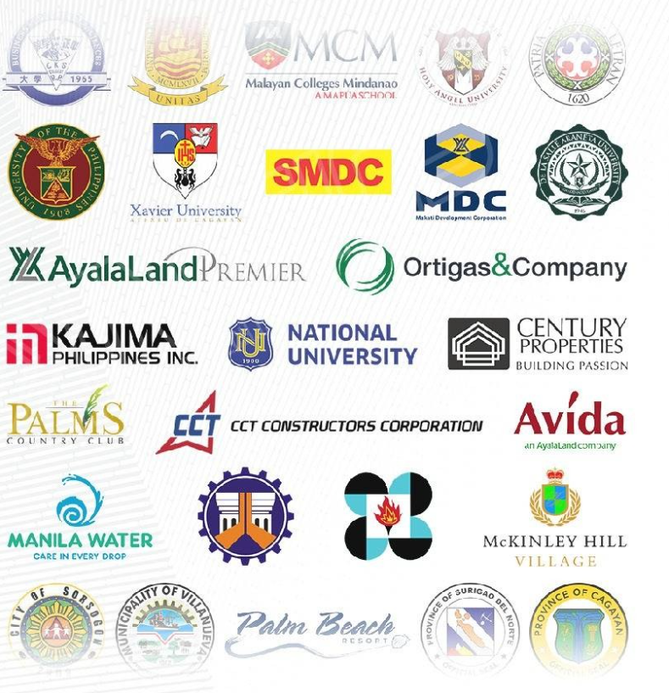

WINNING TOGETHER.

A POSITIVE-SUM SENARIO

We see this opportunity for everyone to gain.

The solutions that we provide add great value to your events and provide more capability to the facility.

Enrich the experience of our audience and equip your facility with flexibility for the future,.

